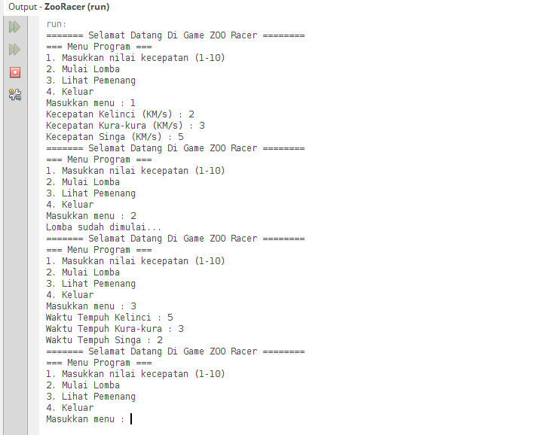

Keterangan Source Code :

-----------------------------------------------------------------------------------------------------------------------------------------------------------------------------------------------------------------------------------------------------------------------------------------------------------------------------------------------------------------------------------------------------------------------------------------------------------------------------------------------------------------------------------------------------------------------------------------------------------------------------------------------------------------------------------------------------------------------------------------------------------------------------------------------------------------------------------------------------------------------------------------------------------------------------------------------------------------------------------------------------------------------------------------------------------------------------------------------------------------------------------------------------------------------------------------------------------------------------------------------------------------------------------------------------------------------------------------------------------------------------------------------------------------------------------------------------------------------------------------------------------------------------------------------------------------------------------------------------------